**Level design**

**3 puzzle mechanics:**

**1 – Buttons**

**2 – Elevating platforms**

**3 – Waterflow system**

**How we could use them:**

**1**

- Pressure plates

- Timed buttons

- Activating elevators

- Activating waterflow

- Stopping elevators

- Stopping waterflow

- Extending bridge or platforms

- Shortening bridge or platforms

- Opening doors / pipes

- Closing doors / pipes

- Opening windows or sections in wall (to make water flow through them)

- Closing windows or sections in the wall (to make water flow stop)

Levers or switches

**2**

- Move players / objects

- Constantly moving

- Stopping on different floors

**3**

- Filling objects

- Flowing on to wheels to turn them

- slowing player characters

- Elevating platforms

- Knocking characters from platforms

- Hiding rooms behind waterfall

- Underwater levels

- the water could have different properties, damages, slows increases speed for a limited time

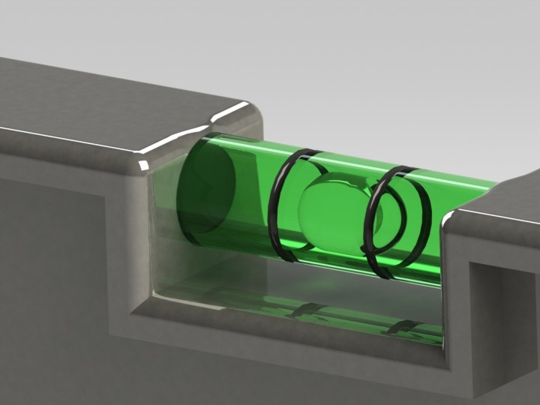**Design ideas**

We could use the pipes to transport objects to the player.

We could use water flowing in pipes to guide the player to the source to help them solve a puzzle/Level.

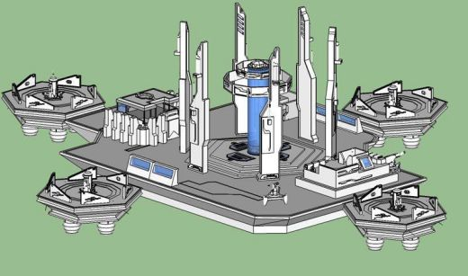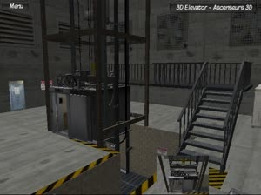

We could use a water tower in the level like the image shows, we could use connecting pipes to transfer water to different areas for example turning a wheel to open a door.

Image found at - https://www.gamasutra.com/blogs/HuguesBarlet/20140907/225061/Block_design_in_level_design.php